Welcome TO

FIG TREE FARM ON THE CHESAPEAKE BAY
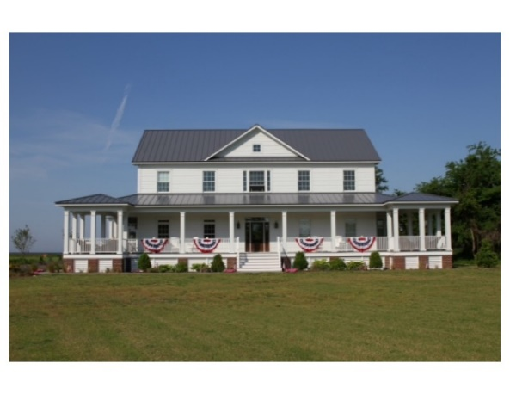

Custom Built With Green Construction Technology
From the wrap around porches to the Post and Beam Great Room, this home was built for relaxing.
THE MAIN FLOOR
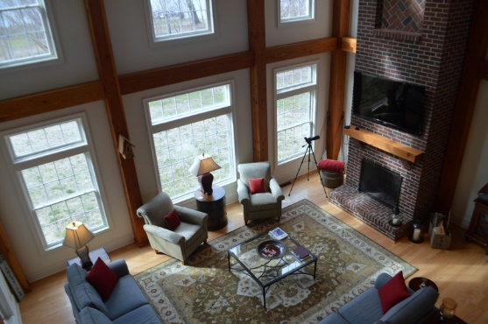
The Living Room adds a flair of the rustic, with its high ceilings, 2-story brick fireplace, and large Post and Beam Trusses.
The Kitchen and eat-in/breakfast room, to the left of the living room, opens up through two French Doors into a screened porch, perfect for large family gatherings. Beautiful granite and custom built cabinets compliment the rustic wood while smoothing the rough and rustic into a sleek, modern work space.
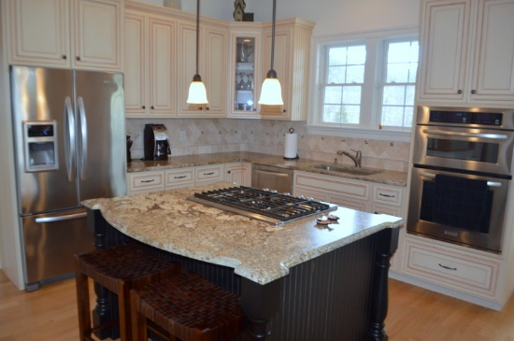
Stainless appliances, punctuated by an island top, 5-burner gas range, give you the quality and durability gourmet cooks want with lots of room for entertaining.
The Mudroom Expands into a Laundry, and simultaneously serves as the main thoroughfare for family and guests. The same custom cabinets in your kitchen flow into this room to serve as a pantry and a place to gear up or stow jackets and boots. Full sized stackable washer and dryer sit next to a separate sink with more counter space and storage.
The Master Bedroom Suite is also on the first floor. With views from both bed and bath. A private deck for coffee in the morning or to watch the sun set over the Bay. Spacious Master Closet. Separate Tub and Shower, both with room for two.
The remainder of the main floor comprises the Foyer, a Powder Room and the Switchback Stairway that leads to the upper level loft, currently serving as the most beautiful and comfortable office on the planet. Go ahead, prove us wrong.
THE UPPER LEVEL:
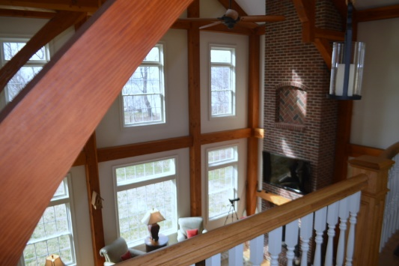

THE “OFFICE”/Loft is large enough for a second living room. Looks out over the Great Room, through the post and beam, to the Bay. On the Bayside of the loft is a room currently serving as storage and utility for office fax, etc. This room was roughed-in during construction in case of the need or desire for an additional bathroom.
Guest bedroom number one sits over the Master, with some of the best views in the house. From here you can watch the local bald eagles as they breakfast in the trees just outside the window.
Guest bedroom number two also provides beautiful views with lots of space to unwind.
Upstairs Guest Bath is built to serve several guests with the amenities of a master bathroom.
The in-law suite over the garage is perfect for guests to stay for extended periods of time. Kids coming home from college. Friends from Auld Lang Synge. This space has a half kitchen, a full bath, and plenty of room for both a sleeping area and a dining/living area.
AND….
Acreage- Lots to tell… 77 acres of elevated land. Beautiful, private sandy beach. Woods and Fields are full of game if you are a hunter. Plenty of Wild Turkey and Deer. Fields are large enough for a stable full of horses.
Separate Barn – This huge barn can handle all of your needs. From storage of Farm equipment, making room for your horses and tack, restoring vintage cars, just plain tinkering.
Breakwaters – You are protected. In addition to building the house well above code for high wind situations, the original owner invested in a large set of Breakwaters to preserve the shoreline and protect your land from erosion.
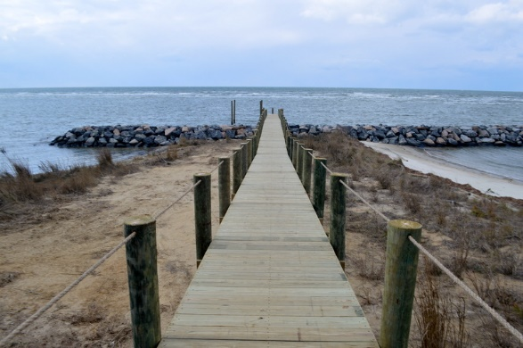

Dock – Your own Bayfront dock! Don’t see that very often. Perfect for fishing in your Carolina Skiff, the dock crosses the main breakwater and puts you in your boat. Complete with a fish cleaning station, power, electricity and a brand new 10,000 LB boat lift. And a bench for just sittin’ and watching those sunsets. Yep, life’s easier on Virginia’s Eastern Shore. Come join us.

